**Mini Project Report**

**Sun Tracking Solar Panel**

Submitted by

**Vardaan Sharma (Roll No.: 2100910310168)**

**Sahil Khan (Roll No.: 2100910310118)**

**Sambhav Saxena (Roll No.: 2100910310121)**

**Vipul Jain (Roll No. 2100910310171)**

Under the Supervision of

**Faculty Coordinator:**

**Mr. Rakesh Kumar & Ms. Pooja Pandey**

*Submitted to the Department of Department of Electronics and Communication Engineering*

**Bachelor of Technology**

*in*

**Electronics and Communication Engineering**



**JSS Academy of Technical Education, Noida**

**C-20/1, Sector – 62, Noida- 201301**

**Dr. APJ Abdul Kalam Technical University**

**2021-22**

**DECLARATION**

We hereby declare that my Project Report titled “Sun Tracking Solar Panel” is a Bonafede record of the project work which we have submitted to JSS Academy of Technical Education, Noida in partial fulfillment of the credit requirements for the degree of Bachelor of Technology is our authentic work. This project report has not been copied, duplicated, or plagiarized from any other paper, journal, document, or book and has not been submitted to any educational institute or otherwise for the award of any certificate, diploma, degree or recognition.

This is an authentic piece of work and in case there is any query regarding the same, we shall be held responsible for answering any queries in this regard

**CERTIFICATE**

This is to certify that the Project Report entitled “Sun Tracking Solar Panel” which is submitted by Vardaan Sharma (2100910310168), Sahil Khan (210091310118) & Sambhav Saxena (2100910310121) & Vipul Jain (2100910310171) in partial fulfillment of the requirement for the curriculum of B. Tech second Year in the Department of Electronics and Communication Engineering of Dr. APJ Abdul Kalam Technical University, is a record of the candidate's completed the mini project under my/our supervision. The mini project report has been submitted successfully to the record of the department.

Mentor: Arpan Sir Coordinator: Mr. Rakesh Kumar & Ms. Pooja Pandey

Date: Date:

**ACKNOWLEDGEMENT**

We would like to express our special thanks of gratitude to The JSSATE Noida, our Faculty Coordinators Mr. Rakesh Kumar and Ms. Pooja Pandey, Student Coordinators Abhimanyu, Gokaran, Yash Jain, Samarth, Arpan & Vanshika and all Senior Quanta Members who all gave us the golden opportunity to do this wonderful, valuable, knowledge gaining mini project - “Sun Tracking Solar Panel” with the implementation of Arduino UNO, Servo Motor, LDR etc. under their worthy guidance.

Any work of this magnitude requires input, efforts, and encouragement from people from all sides. In compiling this project, we have been fortunate enough to get active and kind cooperation from many people without which my endeavors wouldn’t have been a success. The project work has been successful by the cumbersome effort of the faculties.

Last but not the least, we are grateful to our parents and family members and colleagues, for their continuous support and encouragement in the success of this project.

*Signature:*

*Name : Vardaan Sharma*

*Roll No.: 2100910310168*

*Date :*

*Signature:*

*Name : Sahil Khan*

*Roll No.: 2100910310118*

*Date :*

*Signature:*

*Name : Sambhav Saxena*

*Roll No.: 2100910310121*

*Date :*

*Signature:*

*Name : Vipul Jain*

*Roll No.: 2100910310171*

*Date :*

**ABSTRACT**

The main goal of our project is to increase energy efficiency of normal solar panel. It’s exceptionally necessary to increase efficiency of the solar panel to increase their viability as energy needs around the world are increasing at a rapid pace.

This mini project is implemented with the help of Arduino UNO, Servo Motor, LDR (light dependent resistors) and Solar Panel. There are two main objectives of doing the project. First objective is to design an energy efficient and user-friendly solar panel which can move to the direction on sunlight falling on its surface. Secondly to make it in order to make a better case for solar panel implementation as a renewable source of

The report puts forward a kind of mechanism design scheme, this mechanism moves the solar panel in the direction on sunlight falling on its surface with the help of LDR sensors.

The present solar panel that we use is very useful and amazing technological innovation, but this rotation mechanism helps it’s efficiency increase by around 33%”.

**TABLE OF CONTENTS**

**PARTICULARS**

* DECLARATION
* CERTIFICATE
* ACKNOWLEDGEMENT
* ABSTRACT

1. **INTRODUCTION (CHAPTER I)**

1.1 About Sun Tracking Solar Panel

1.2 What is Automation

1.3 Objectives

1.4 Scope of the Project

1.5 Significance

1. **DESIGN & METHODOLOGY (CHAPTER II)**

2.1 Hardware Requirements

2.2 Description of Hardware

2.3 Software Requirement

2.4 Arduino Code

2.5 Block Diagram

**3. IMPLEMENTATION & RESULT (CHAPTER III)**

3.1 Circuit Diagram

3.2 Testing

3.3 Results

**4. CONCLUSION (CHAPTER IV)**

**5. REFERENCES**

**LIST OF FIGURES**

|  |  |
| --- | --- |
| **FIGURE** | **NAME** |
| Fig. 2.1 | Arduino UNO |
| Fig. 2.2 | Servo Motor |
| Fig. 2.3 | LDR Sensors |
| Fig. 2.4 | Jumper Wires |
| Fig. 2.5 | Solar Panel |
| Fig. 2.6 | Block Diagram |
| Fig. 3.1 | Circuit Diagram |
| Fig. 3.2 | Working Model |

**CHAPTER I: INTRODUCTION**

* 1. **About Sun Tracking Solar Panel**

We use Solar Panel a lot in large solar farms, but their efficiency is less due to the sun rays changing direction throughout the day. To cope up with this problem we have designed our Sun tracking solar panel such that with the moving sun rays our panel will also move with the help of the servo motor attached on it and would make the panel more efficient and it will put forward the case for solar panels as the foremost renewable source of energy.

**1.2 What is Automation?**

Automation or automatic control is the use of various control systems for operating equipment such as machinery, processes in factories, boilers and heat-treating ovens and other applications with minimal or reduced human intervention. Some processes have been completely automated.

The biggest benefit of automation is that it saves labor; however, it is also used to save energy and materials and to improve quality, accuracy and precision.

**1.3 Objective**

There are two main objectives of doing the project. First objective is to design a energy efficient and user-friendly solar panel which can move to the direction on sunlight falling on its surface. Secondly to make it in order to make a better case for solar panel implementation as a renewable source of

The report puts forward a kind of mechanism design scheme, this mechanism moves the solar panel in the direction on sunlight falling on its surface with the help of LDR sensors.

The present solar panel that we use is very useful and amazing technological innovation, but this rotation mechanism helps its efficiency increase by around 33%”.

The principal object of the project is to increase and make this system more efficient and to make case for solar energy to be used as a primary source of renewable energy sources.

**1.4 Significance**

* Reduce energy loss.
* To increase efficiency of a normal solar panel.
* To make solar panel implementation more viable.
* Make use of Solar Energy to the fullest.
* Make the use case of Solar as the fore most renewable energy source.
* Promote Renewable Energy alternatives.

**CHAPTER II: DESIGN & METHODOLOGY**

* Sun Tracking Solar Panel Works with Help of LDR (Light Dependent Resistor) That Are Installed on Either Side of The Panel.
* The Servo Motor Helps the Panel Rotate to The Direction of The Sunlight.
* Arduino Communicates with Servo Motor and LDR Sensors Making the Operation Possible.
* This Whole Setup Is Completed with Connections with The Help Jumper Wires and Bread Board.
* This Whole Setup Is Put together with A Rigid Stand Made by Our Team from Cardboard.

**2.1 Hardware Requirements**

* Arduino UNO
* Solar Panel
* Servo Motor
* Jumper Wires
* LDR
* Breadboard
* Resistors
  1. **Description of Hardware**
* **Arduino UNO:** The Arduino Uno is an [open-source](https://en.wikipedia.org/wiki/Open-source) [microcontroller board](https://en.wikipedia.org/wiki/Microcontroller_board) based on the [Microchip](https://en.wikipedia.org/wiki/Microchip_Technology) [ATmega328P](https://en.wikipedia.org/wiki/ATmega328P) microcontroller and developed by [Arduino.cc](https://en.wikipedia.org/wiki/Arduino) and initially released in 2010. The board is equipped with sets of digital and analog [input/output](https://en.wikipedia.org/wiki/Input/output) (I/O) pins that may be interfaced to various [expansion boards](https://en.wikipedia.org/wiki/Expansion_board) (shields) and other circuits. The board has 14 digital I/O pins (six capable of [PWM](https://en.wikipedia.org/wiki/Pulse-width_modulation) output), 6 analog I/O pins, and is programmable with the [Arduino IDE](https://en.wikipedia.org/wiki/Arduino#Software) (Integrated Development Environment), via a type B [USB cable](https://en.wikipedia.org/wiki/USB_cable). It can be powered by the USB cable or by an external [9-volt battery](https://en.wikipedia.org/wiki/9-volt_battery), though it accepts voltages between 7 and 20 volts.

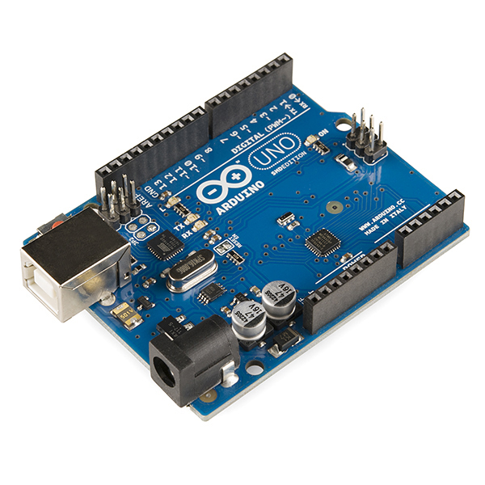

Fig. 2.1

* **Servo Motor:** Provides rotation to the axis of the solar panel with help of the commands it receive from the Arduino Uno.

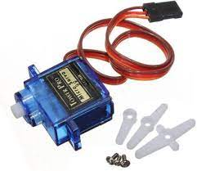

Fig. 2.2

* **LDR Sensor (8 mm):** Light dependent resistors that provide the necessary information to the servo motor through Arduino in order to make the solar panel rotate towards the direction of the sun light**.**

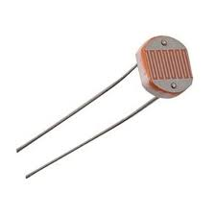

Fig. 2.3

* **Solar Panel:** The solar panel is the primary component of the system that absorbs the energy of the sun rays and provide electricity.

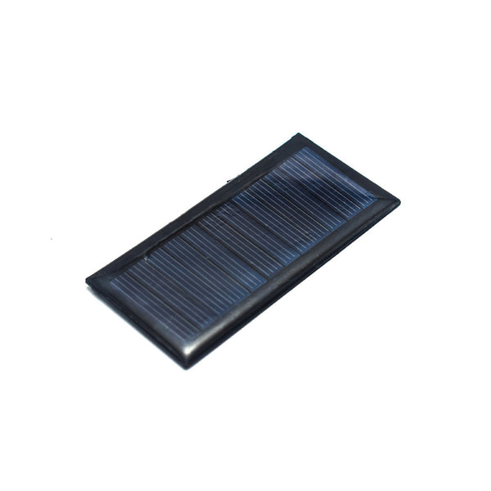

Fig. 2.4

* **Jumper Wires:** Jumper wires are simply wires that have connector pins at each end, allowing them to be used to connect two points to each other without soldering. Jumper wires are typically used with [breadboards](https://blog.sparkfuneducation.com/what-is-a-breadboard) and other prototyping tools in order to make it easy to change a circuit as needed.

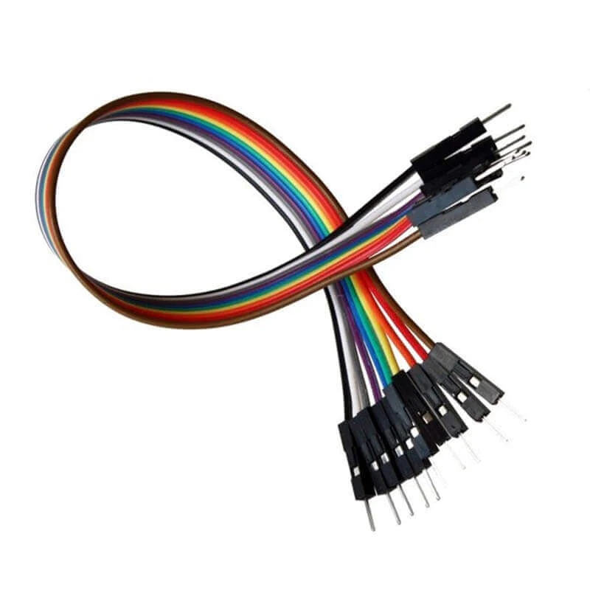

Fig. 2.5

**2.3 Software Requirement:**

The Arduino Integrated Development Environment - or Arduino Software (IDE) - contains a text editor for writing code, a message area, a text console, a toolbar with buttons for common functions and a series of menus. It connects to the Arduino hardware to upload programs and communicate with them.

**2.4 Arduino Code:**

#include <Servo.h> //including the library of servo motor

Servo myservo;

int initial_position = 90;

int LDR1 = A0; //connect The LDR1 on Pin A0

int LDR2 = A1; //Connect The LDR2 on pin A1

int error = 5;

int servopin=9; //You can change servo just makesure its on arduino's PWM pin

void setup()

{

myservo.attach(servopin);

pinMode(LDR1, INPUT);

pinMode(LDR2, INPUT);

myservo.write(initial_position); //Move servo at 90 degree

delay(2000);

}

void loop()

{

int R1 = analogRead(LDR1); // read LDR 1

int R2 = analogRead(LDR2); // read LDR 2

int diff1= abs(R1 - R2);

int diff2= abs(R2 - R1);

if((diff1 <= error) || (diff2 <= error)) {

} else {

if(R1 > R2)

{

initial_position = --initial_position;

}

if(R1 < R2)

{

initial_position = ++initial_position;

}

}

myservo.write(initial_position);

delay(100);

}

**2.5 Block Diagram:**

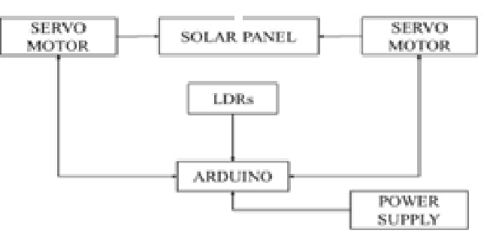

Mounik D Rupaniet al. Int. Journal of Engineering Research and Applications www.ijera.com ISSN : 2248-9622, Vol. 5, Issue 5, ( Part -5) May 2015, pp.48-51

Fig. 2.6

**CHAPTER III: IMPLEMENTATION & RESULT**

**3.1 Circuit Diagram:**

https://roboids.blogspot.com/2021/09/to-make-arduino-single-axis-solar.html?m=1

Fig. 3.1

**3.2 Testing:**

By taking a trial of our machine and gathering all the information about the other methods, the model shows a desired effect of moving the direction of the sunlight with a defined delay of 2 seconds. It is very accurate in its movement.

**3.3 Result:**

We can operate it with the help an energy source for arduino, we are able to make the solar panel rotate in the direction of the sunlight.

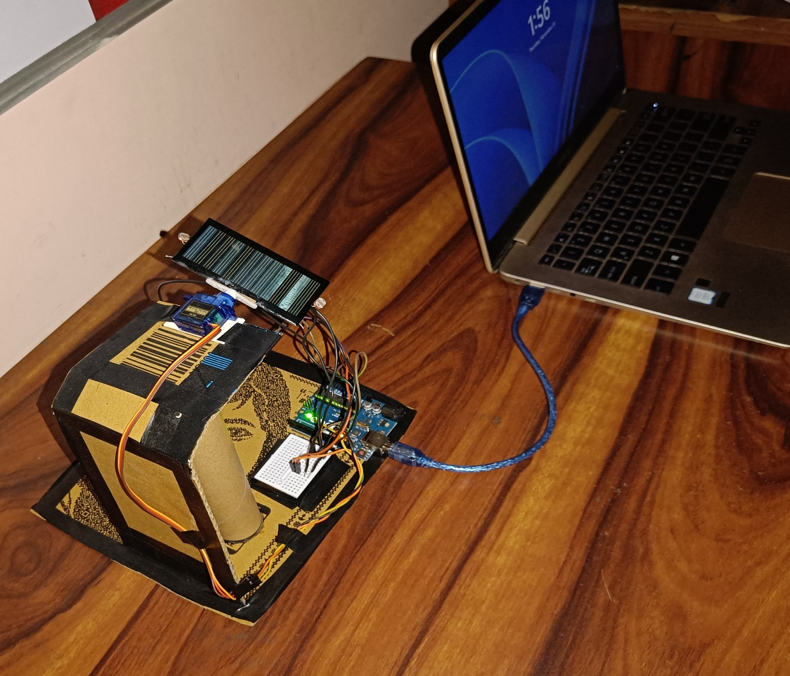

Fig. 3.2

**CHAPTER IV: CONCLUSION**

In the new era of technology, we want innovation and don’t want technological progress to remain stagnant. Our sun tracking solar panel not only provides a hope but also the believe that we can keep innovation continued even though it might feel there is no more path left to innovate.

In similar steps we can make our sun tracking solar panel more efficient by making a 360-degree rotational solar panel which will allow us to even better this efficiency figure and also make the use of the solar panels in general, more viable.

In conclusion, a sun tracking solar panel is designed was designed and make with help of cardboard base structure and this technology can increase the viability of the solar panel many folds make its use very prevalent with its increased efficiency and can put it to the fourth front of renewable energy sources.

**REFERENCE**

**[1] “Efficiency Data - Department of Electrical and Electronics Engineering, Faculty of Engineering, Anadolu University, Eskisehir, Turkey**

**[2] “Model Design and Inspiration -** [Single Axis Solar Tracker (roboids.blogspot.com)](https://roboids.blogspot.com/2021/09/to-make-arduino-single-axis-solar.html?m=1)